**ASDM Module Exam (02-02-2023) PRN** -  **220940520103**

- - - - - - - - - - - - - - - - - - - - - - - - - - - - - -- - - - - - - - - - - - - - - - - - - - - - - - - - - - - - - - - - - - -

**Section** **1**

The code to test the web link given in question ,should make use of all the various applicable locators like Id, name, class, tagname, cssSelector, xpath, linktext, partial linktext to traverse the web element and do the needful steps in the question:

**Question1)**

**Write a Script to do following to test the https://www.facebook.com/ website using**

**Selenium**

**a) Open the url [4marks]**

**b) Go to SignUp [3marks]**

**c) Click on create a new account [ 3marks]**

**d) Fill the data and signup [5marks]**

**e) Print the title of page [2marks]**

**f) get CurrentURL [1marks]**

**g) Navigate page to back [2marks]**

**Solution:**

package exam_testing;

import org.openqa.selenium.chrome.ChromeDriver;

public class exam_220940520103 {

ChromeDriver driver;

**a) Open the url [4marks]**

public void open()

{

System.*setProperty*("webdriver.chrome.driver", "C:\\Users\\Suraj\\Documents\\Eclipse\\Selenium\\chromedriver.exe");

driver = new ChromeDriver();

driver.get(facebook);

driver.manage().window().maximize();

driver.manage().deleteAllCookies();

String Title=driver.getTitle();

**e) Print the title of page [2marks]**

System.***out***.println("Title of page"+Title);

**f) get CurrentURL [1marks]**

String urlFromBrowser = driver.getCurrentUrl();

System.***out***.println("URL of page"+urlFromBrowser);

}

**b) Go to SignUp [3marks]**

public void signup()

{

driver.navigate().to("https://www.facebook.com/signup");

**c) Click on create a new account [ 3marks]**

driver.findElement(By.*xpath*("/html/body/div[1]/div[1]/div[1]/div/div/div/div[2]/div/div[1]/form/div[5]/a")).click();

**d) Fill the data and signup [5marks]**

driver.findElement(By.*name*("firstname")).sendKeys("Suraj");

driver.findElement(By.*name*("lastname")).sendKeys("Salunkhe");

driver.findElement(By.*name*("reg_email__")).sendKeys("8451920040");

driver.findElement(By.*id*("password_step_input")).sendKeys("Suraj@123");

Select selDate = new Select(driver.findElement(By.*id*("day")));

Select selMonth = new Select(driver.findElement(By.*id*("month")));

Select selYear = new Select(driver.findElement(By.*id*("year")));

selDate.selectByVisibleText("20");

selMonth.selectByVisibleText("Aug");

selYear.selectByVisibleText("1996");

driver.findElement(By.*xpath*("//input[@type='radio' and @value='2']")).click();

driver.findElement(By.*xpath*("//button[text()='Sign Up']")).click();

**g) Navigate page to back [2marks]**

driver.navigate().back();

}

public static void main(String[] args) {

// **TODO** Auto-generated method stub

exam_220940520103 o = new exam_220940520103();

o.open();

o.signup();

}

}

**Output:**

**a) Open the url [4marks]**

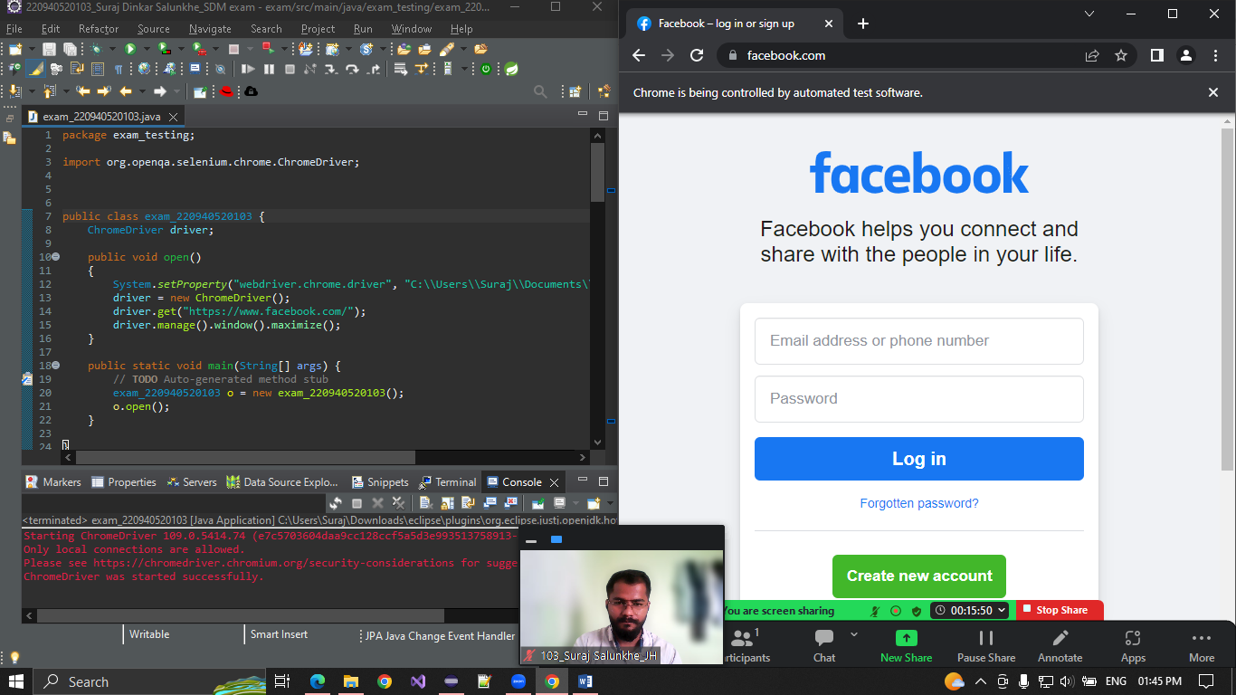

**b) Go to SignUp [3marks]**

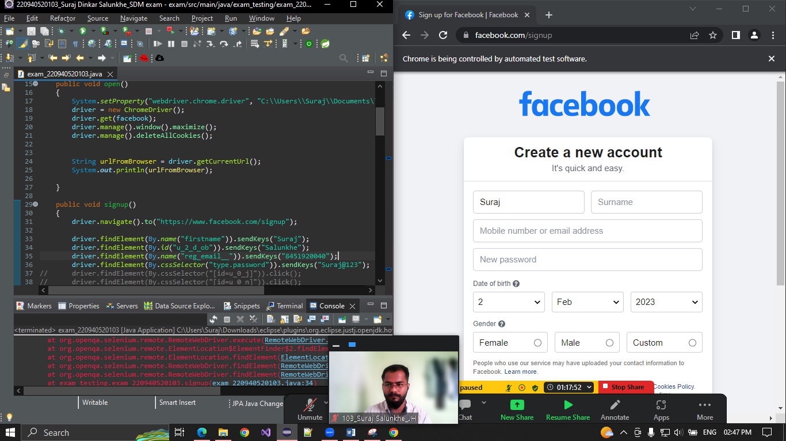

**c) Click on create a new account [ 3marks]**

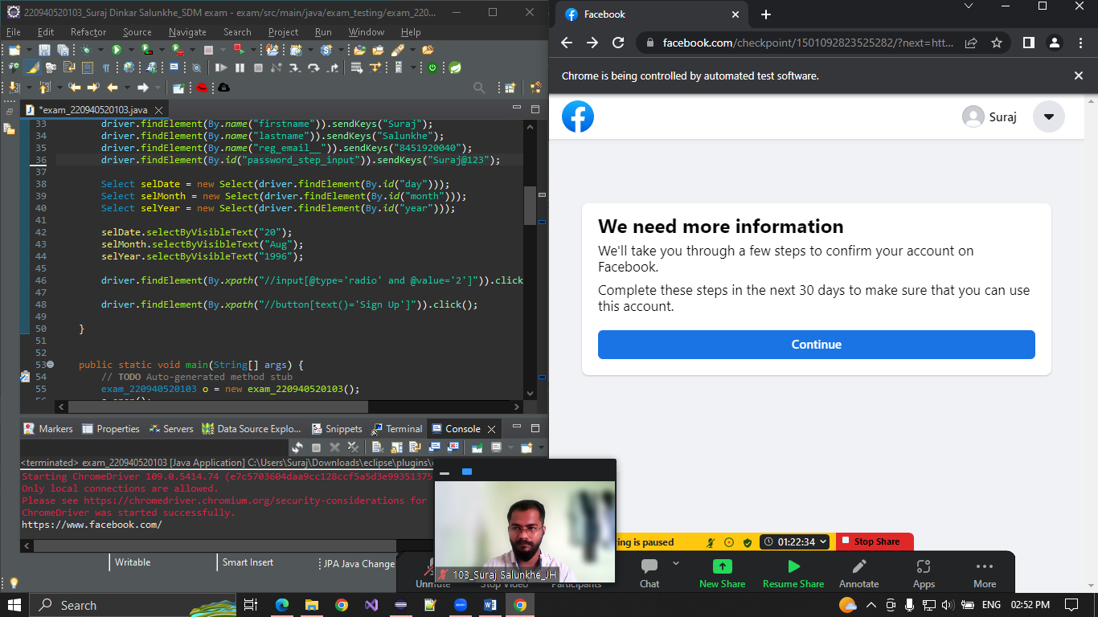

**d) Fill the data and signup [5marks]**

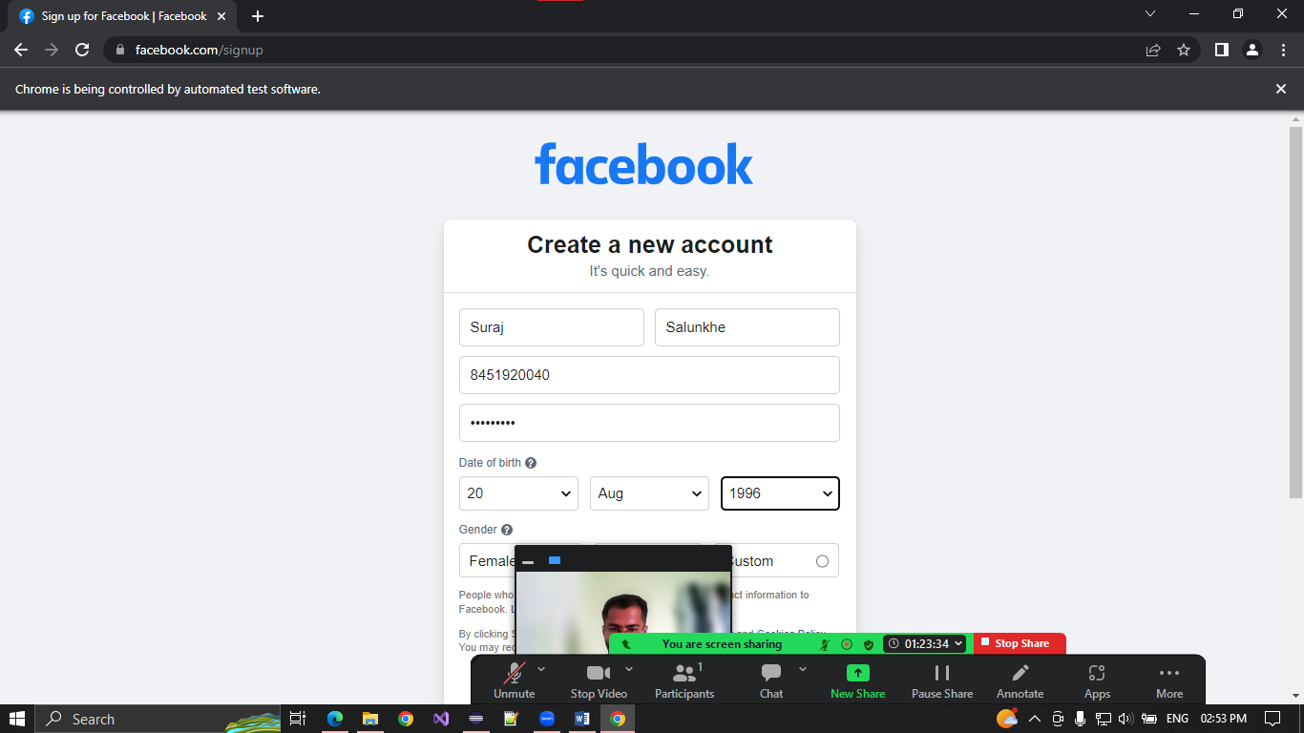

**e) Print the title of page [2marks]**

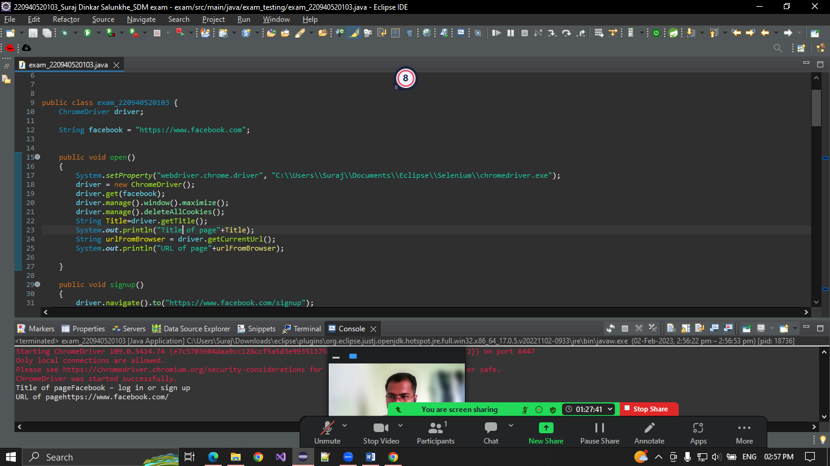

**f) get CurrentURL [1marks]**

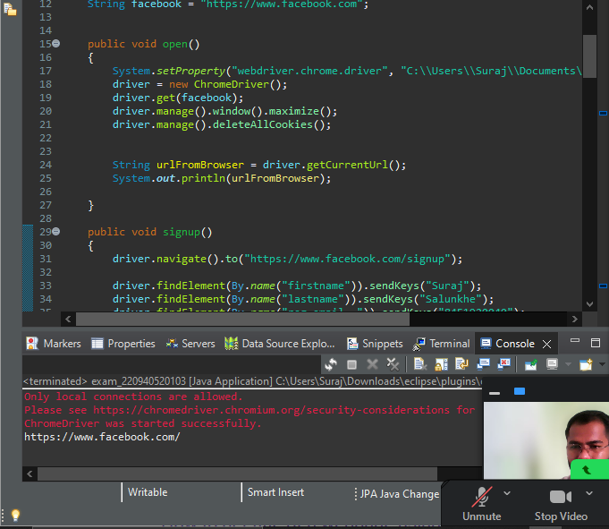

**g) Navigate page to back [2marks]**

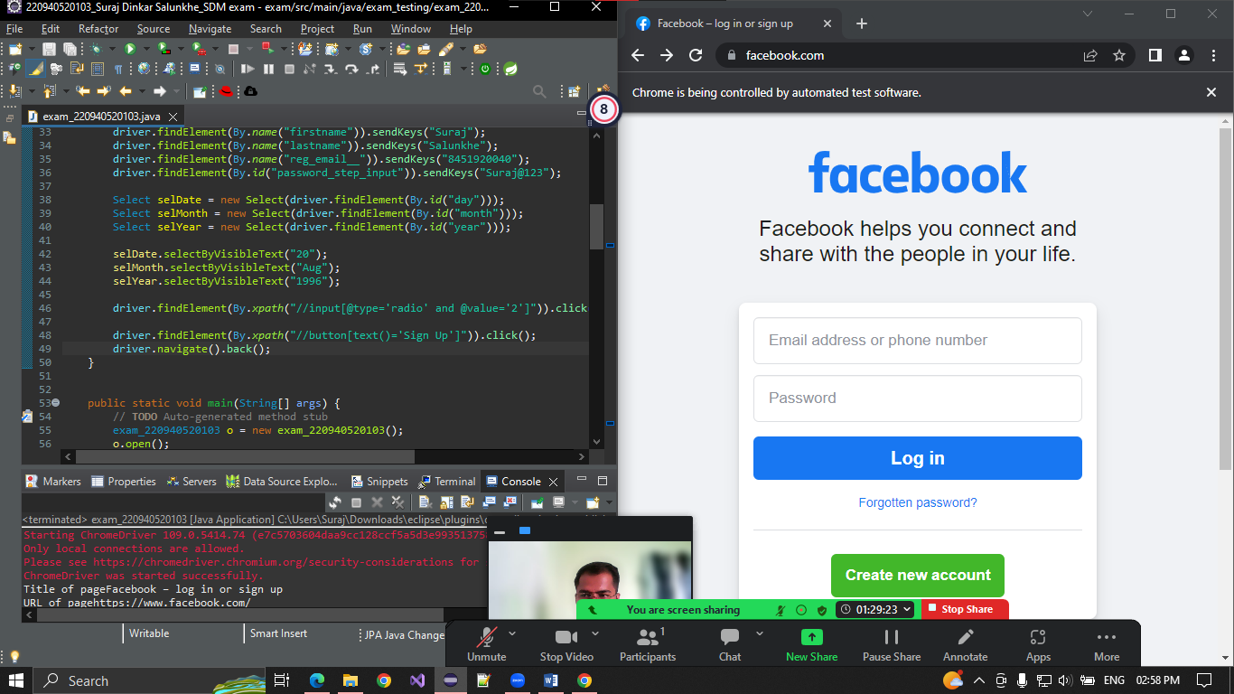

- - - - - - - - - - - - - - - - - - - - - - - - - - - - - -- - - - - - - - - - - - - - - - - - - - - - - - - - - - - - - - - - - - -

**Question** **2)**

**Solution:**

**Output:**

**CMD Snapshot:**

**Test Cases:**

**Test Case**